### LAB REPORT

***Submitted by***

**S.Chetan [RA2011003010904]**

**K.Udhayakumar[RA2011003010935]**

**Rohit[RA2011003010913]**

***Under the Guidance of***

**Ms.Naga Devi**

##### Assistant professor, Department of Computing Technologies

***In partial satisfaction of the requirements for the degree of***

# BACHELOR OF TECHNOLOGY

**in**

# COMPUTER SCIENCE ENGINEERING



**SCHOOL OF COMPUTING**

# COLLEGE OF ENGINEERING AND TECHNOLOGY SRM INSTITUTE OF SCIENCE AND TECHNOLOGY KATTANKULATHUR - 603203

### JUNE 2022



SRM INSTITUTION OF SCIENCE AND TECHNOLOGY KATTANKULATHUR-603203

# BONAFIDE CERTIFICATE

Certified that this lab report titled **student performance details** is the bonafide work done by Chetan[RA2011003010904],Udhayakumar K[RA2011003010935],Rohit[RA2011003010913] who carried out the lab exercises under my supervision. Certified further, that to the best of my knowledge the work reported here in does not form part of any other work.

##### SIGNATURE

##### Ms.Nagadevi

##### SEPM – Course Faculty

##### Assistant professor

**Department of Computing Technologies**

##### ABSTRACT

With reference to this document; it specifically mentions the details of the project how it was developed, the primary requirement, as well as various features and functionalities of the project and the procedure followed in achieving these functionalities. This structured system deals with the scores of students in various subjects he opted for during an academic year.

For this research, students' scores across few important measures that tries to determine their academic excellence such as subjects conceptual knowledge based on marks scored in that exam, Time management skills based on number of questions attempted is obtained priorly, have been used to create homogeneous groups of students who opted for same subjects and share perceptions of their non-cognitive abilities. Result of statistical graphical data helps students and teachers to track the performance and direction in which the students perception and knowledge regarding the subject is inculcated. Results of this study indicate the degree to which specific profiles predict outcome of the conceptually relevant data and widen the scope of their information to discover knowledge from data. Also it facilitates smooth and efficient handling of data that includes storage and modification of data in files which can be easily converted to other formats as desired by the user.

**TABLE OF CONTENTS**

|  |  |  |
| --- | --- | --- |
| **CHAPTER NO** | **TITLE** | **PAGE NO** |
|  | **ABSTRACT** | **iii** |
|  | **LIST OF FIGURES** | **v** |
|  | **LIST OF ABBREVIATIONS** | **vi** |
| **1** | **PROBLEM STATEMENT** | **1** |
| **2** | **STAKEHOLDERS & PROCESS MODELS** | **3** |
| **3** | **IDENTIFYING REQUIREMENTS** | **5** |
| **4** | **PROJECT PLAN & EFFORT** | **6** |
| **5** | **WORK BREAKDOWN STRUCTURE & RISK ANALYSIS** | **9** |
| **6** | **SYSTEM ARCHITECTURE, USE CASE & CLASS** | **12** |
|  | **DIAGRAM** |  |
| **7** | **ENTITY RELATIONSHIP DIAGRAM** | **15** |
| **8** | **DATA FLOW DIAGRAM** | **16** |
| **9** | **SEQUENCE & COLLABORATION DIAGRAM** | **19** |
| **10** | **DEVELOPMENT OF TESTING** | **21** |
|  | **FRAMEWORK/USER INTERFACE** |  |
| **11** | **TEST CASES & REPORTING** | **24** |
| **12** | **ARCHITECTURE/DESIGN/FRAMEWORK/IMPLE** | **26** |
|  | **-MENTATION** |  |
|  | **CONCLUSION** | **38** |
|  | **REFERENCES** | **38** |

##### LIST OF FIGURES

|  |  |  |
| --- | --- | --- |
| **FIGURE NO** | **TITLE** | **PAGE NO** |
| **1.0** | **logo** | **1** |
| **2.1** | **Process model** | **3** |
| **5.1** | **WBS** | **9** |
| **5.2** | **Project plan** | **10** |
| **5.3** | **Project timeline** | **10** |
| **5.4.1** | **Swot analysis** | **11** |
| **6.1.1** | **System architecture** | **12** |
| **6.2.1** | **Use case diagram** | **13** |
| **6.3** | **Class diagram** | **14** |
| **7.1** | **Entity diagram** | **15** |
| **8.2.1** | **DFD L-1** | **17** |
| **9.1.1** | **sequence diagram** | **19** |
| **9.2.1** | **Collaboration diagram** | **20** |
| **10.2.1** | **Home page** | **23** |

**LIST OF ABBREVIATIONS**

ER -Diagram Entity Relationship CAPEX -Capital expenditures WBS -Work Breakdown Structure

SWOT -Strength, Weakness,Opportunities, Threats RMMM-Risk Mitigation, Monitoringand Management DFD-Data flow diagram

##### CHAPTER-1 PROBLEM STATEMENT-LOGO

To Frame a project team, analyze and identify a Software project. To create a business case and Arrive at a Problem Statement for the student performance.

|  |  |
| --- | --- |
| **DATE** | 15-03-2021 |
| **SUBMITTED**  **BY** | udhayakumar, Chetan,Rohit |
| **TITLE / ROLE** | Student performance |

fig.1.0 logo

##### PROBLEM STATEMENT

The proposed project “Student Performance details” is the process where students can check the average marks and analyse which helps to improve overall career in real-time without an intermediary service over the Internet. The Given System provides the detailed working of the Student Performance details Processing

##### Project Description :-

* + 1. Student Performance details is an application which refers to other analysis systems like the car quality analysis, Share Market analysis and in broad perspective Data Analysis.
    2. It is developed to help teachers i.e. Faculty and Students enrolled in particular course in terms of their performance in that course and is useful for maintenance of records as well.
    3. DBA can implement, update, modify and can maintain the system and can develop the system for future use as per the needs of the users.

|  |
| --- |
| **1.3 THE PROJECT**  In bullet points, describe the problem this project aims to solve or the opportunity it aims to develop. |
| * The goal of online student performance analysis system is to develop software produce high quality software. The goal of the system is achieved and difficulties are solved. * “Student Performance with Academic Project Work Reporting System” |
| **1.4 THE HISTORY** |
| * In today’s world technology has reached to extent that it can be used to do various task in day-to-day life easily with less effort and time. * World today has realized importance of education in one’s life which has led to revolution in field of education. Universities, colleges, schools today have loads of task to be completed in given timeline. * In today’s scenario colleges needs to analyze student performance manually which takes a lot of time and effort by faculties working on it. |
| **1.5 LIMITATIONS**  List what could prevent the success of the project, such as the need for expensive equipment, bad weather, lack of special training, etc. |

|  |
| --- |
| * The database may get crashed at any certain time due to virus or operating system failure. Therefore, it is required to take the database backup. * the main function is managing and maintaining information. It will be ensured that the information entered is of the correct format. |
| **1.6 APPROACH**  List what is needed to complete the project. |
| * We are recquired to analyze and generate report of students based on the curriculum that represents student’s academic performance. * We have developed the system such that, it will automatically parse data onto the database from excel file, which will in return reduce time consumption of analysis of data * data is been fetched dynamically through the database. For here, parsing is done using PHP Excel. * It is an inbuilt library for python to fetch data from excel files over or within network. * We hope to accelerate the analysis by developing the analysis system. * It provides assistance to teachers and administrator to track record of each student, subject and department by using various techniques like libraries |
| **1.7 BENEFITS**  list the benefits that this project will bring to the organization. |
| * In bullet points, Student Performance Analyser (SPA) * Intelligent Mining and Decision Support. * proposed system to make sure the objectives are achieved. * Able to help lecturers to automatically predict. * Able to keep track and retrieve students' * Able to view the factors that affect the students |

##### CHAPTER-2 STAKEHOLDERS & PROCESS MODELS

To identify the appropriate Process Model for the project and prepare Stakeholder and User Description.

##### 2.1

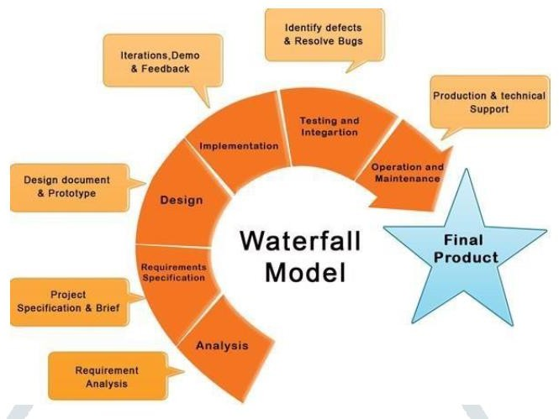

**Fig.2.1 process model**

2.2 SUMMARIZATION OF THE METHODOLOGY:-

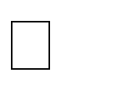Requirements: During this initial phase, the potential requirements of the application are methodically analyzed and written down in a specification document that serves as the basis for all future development. The result is typically a requirements document that defines what the application should do, but not how it should do it.

Analysis: During this second stage, the system is analyzed in order to properly generate the models and business logic that will be used in the application.

Design: This stage largely covers technical design requirements, such as programming language, data layers, services, etc. A design specification will typically be created that outlines how exactly the business logic covered in analysis will be technically implemented.

Coding: The actual source code is finally written in this fourth stage, implementing all models, business logic, and service integrations that were specified in the prior stages.

Testing: During this stage, QA, beta testers, and all other testers systematically discover and report issues within the application that need to be resolved. It is not uncommon for this phase to cause a “necessary repeat” of the previous coding phase, in order for revealed bugs to be properly squashed.

Deployment: Finally, the application is ready for deployment to a live environment. This stage entails not just the deployment of the application, but also subsequent support and maintenance that may be required to keep it functional and up-to-date.

|  |  |  |  |  |  |
| --- | --- | --- | --- | --- | --- |
| sl.no | Stakeholder Name | Activity/ Area /Phase | Interest | Influence | Priority (High/ Medium/ Low) |
| 1. | Owner | Managing resourses | High | High | 1 |
| 2. | Customers | Mobile app with login | High | High | 1 |
| 3. | Supplier | Mobile app with admin login | High | High | 1 |
| 4. | Designer | Provide design to app | High | Low | 2 |
| 5. | Investor | Provie necessary financial resources | Low | High | 2 |
| 6. | Distributor | Distribute the supplies | Low | High | 3 |

##### CHAPTER-3 IDENTIFYING REQUIREMENTS

To identify the system, functional and non-functional requirements for the project

##### System Requirements

* + 1. Hardware Requirements:-

Windows: Windows 7 Or Above Processor: i3 Or Above

HDD: 256GB RAM: 2 GB

* + 1. Software Requirements:- Python IDLE ,python libraries Microsoft Excel 2016 for data

Programming Language : Python or c++ or c,html

##### Functional Requirements:-

provides information about Test Performances, detailed analysis of each subject, anytime. provides with immediate updates in the Test performance based on previous test.



It



It

also acts as a platform where the complete academic information about the student. provides Students Test Performance in consolidated and detailed performance sheets.



It



It

analyses students’ performance in different subject so that the student knows where he stands in this competition.



It

##### Non-Functional Requirements:-

This system is specifically developed for the faculty and students. Student’s record can also be maintained.

Faculty and Course details can also be maintained without manual work.

System is fast as compared to traditional system of data storage in files (paper) format and updates can be easily done.

The system’s primary task is analytical.

User friendly environment with real time dynamically generated result optimization.

##### CHAPTER-4 PROJECT PLAN & EFFORT

To Prepare Project Plan based on scope, Calculate Project effort based on resources, Find Job roles and responsibilities.

* 1. Project Management Plan

Describe the key issues driving the project.

|  |  |
| --- | --- |
| **Focus Area** | **Details** |
| schedule management | developing the project and testing the codes. Coding require for the project- 35 days |
| Resource Management | Required minimum of 3 persons to complete the project. Finance: expense of the software and hardware  Physical: Office with system with minimum system requirements |
| Risk Management | The database may get crashed at any certain time due to viruses or some issues with operating system failure.  The accuracy of the data in database |

#### Estimation

* + 1. Effort and Cost Estimation

|  |  |  |  |  |  |
| --- | --- | --- | --- | --- | --- |
| **Activity Description** | | **Sub-Task** | **Sub-Task Description** | **Eﬀort (in**  **hours)** | **Cost in INR** |
| Design the user screen | | E1R1A1T1  (Eﬀort-Require  ment-Activity- Task) | Confirm the user requirements (acceptance criteria) | 3 | 1500 |
| E1R1A1T2 | linking the data with octave or matlab | 1 | 500 |
| E1R1A1T3 | Datafilling | 8 | 4000 |
| Identify Data Source for |  | | Go through Interface | 5 | 2500 |
| displaying units of Energy |  | | contract (Application |  |  |
| Consumption |  | | Data Exchange) |  |  |
|  | | documents |  |  |

|  |  |
| --- | --- |
| **Eﬀort (hr)** | **Cost (INR)** |
| 1 | 500 |

## Infrastructure/Resource Cost

|  |  |  |  |
| --- | --- | --- | --- |
| **Infrastructure Requirement** | **Qty** | **Cost per qty** | **Cost per item** |
| Laptops | 5 | 50000 | 250000 |

* + 1. Maintenance and Support Cost

|  |  |  |  |  |
| --- | --- | --- | --- | --- |
| **Category** | **Details** | **Qty** | **Cost per qty per annum** | **Cost per item** |
| People | Network, System, Middleware and DB admin  Developer , Support Consultant | 4 | s3,000,000 | 12,000,000 |
| License | Operating System Database Middleware  IDE | 10 | 10000 | 100,000 |
| Infrastructures | Server, Storage and Network | 20 | 30000 | 600,000 |

## Project Team Formation

* + 1. Identification Team members

|  |  |  |
| --- | --- | --- |
| **Name** | **Role** | **Responsibilities** |
| CRS Institutions | Key Business User (Product Owner) | Provide clear business and user requirements |
| Rohit | Project Manager | Manage the project |
| Charan | Business Analyst | Discuss and Document Requirements |
| Chetan | Technical Lead | Design the end-to-end architecture |
| Charan | UX Designer | Design the user experience |
| Chetan | Cloud Architect | Design the cost eﬀective, highly available  and scalable architecture |
| Rohit | Cloud Operations | Provision required Services |
| Charan | tester | Define Test Cases and Perform Testing |

## Responsibility Assignment Matrix

|  |  |  |  |  |
| --- | --- | --- | --- | --- |
| **RACI Matrix** | **Team Members** | | | |
| **Activity** | **Name (BA)** | **Name (Developer)** | **Name (Project Manager)** | **Key Business User** |
| User Requirement Documentation | Chetan | Charan | Rohit | CRS  institutions |

|  |  |
| --- | --- |
| A | Accountable |
| R | Responsible |
| C | Consult |
| I | Inform |

##### CHAPTER-5

**WORK BREAKDOWN STRUCTURE & RISK ANALYSIS**

To Prepare Work breakdown structure, Timeline chart and Risk identification table. Project work breakdown structure with timeline chart and risk table is incorporated.

**5.1 Work break down structure**

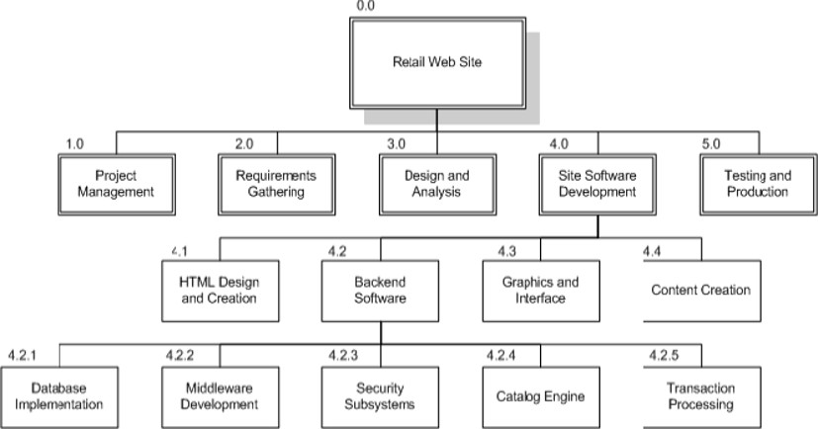

##### Fig.5.1.WBS

* Student Web Site
* Project Management
* Requirements Gathering
* Analysis & Design
* Site Software Development
  + HTML Design and Creation
  + Backend Software

🞄 Database Implementation

🞄 Middleware Development

🞄 Security Subsystems

🞄 Catalog Engine

🞄 Transaction Processing

* + Graphics and Interface
  + Content Creation
* Testing and Production

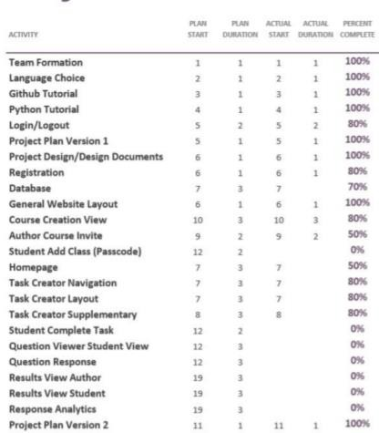

**Fig.5.2 project plan**

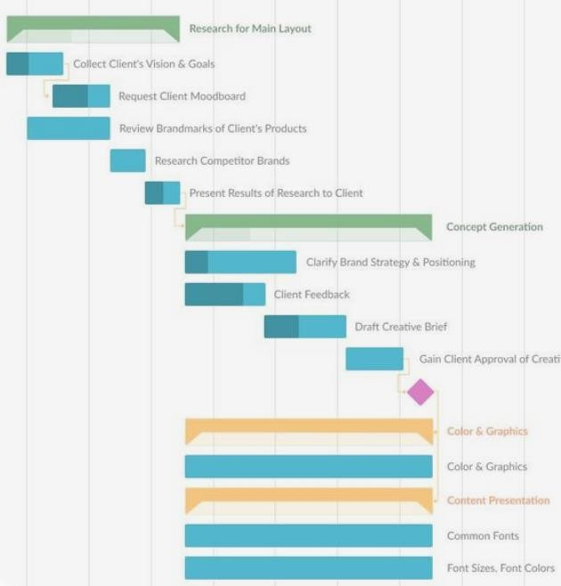

**Fig. 5.3 project time line**

* 1. **SWOT ANALYSIS**

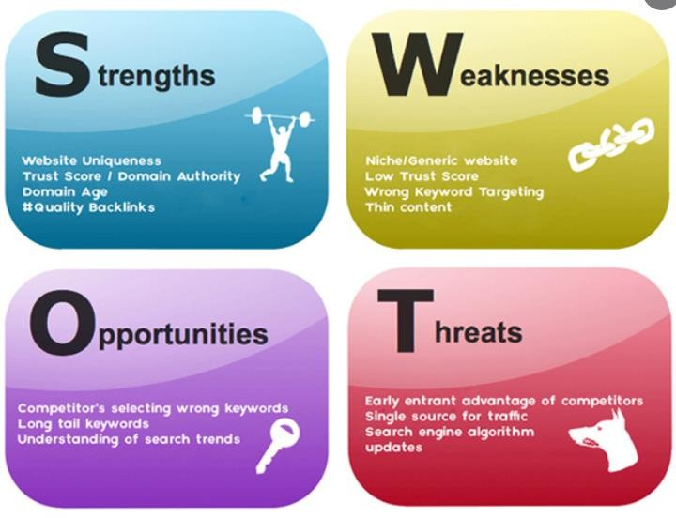

* + 1. **swot analysis**
  1. **RMMM**

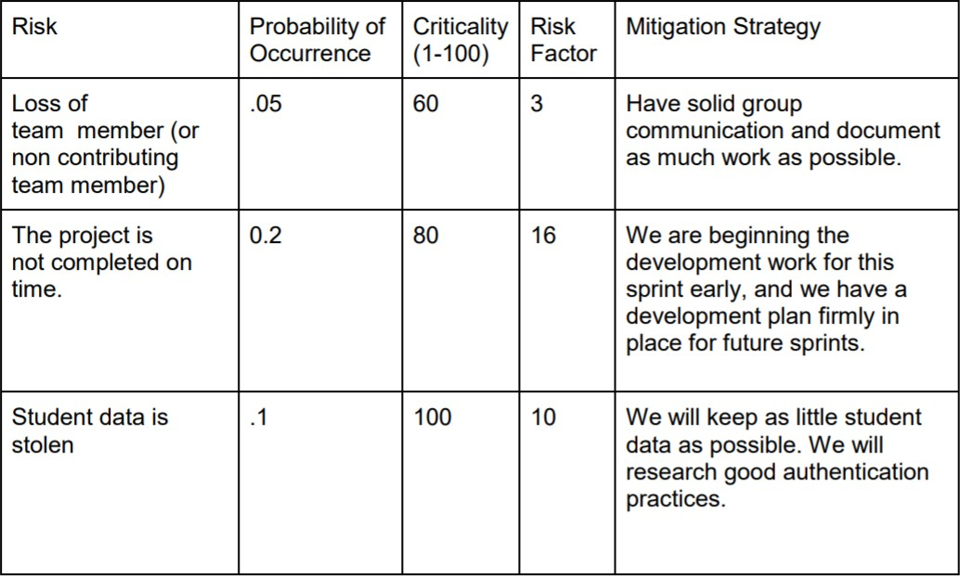

##### CHAPTER-6

**SYSTEM ARCHITECTURE, USE CASE & CLASS DIAGRAM**

To Design a System Architecture, use case and Class Diagram for student performace details.

##### SYSTEM ARCHITECTURE

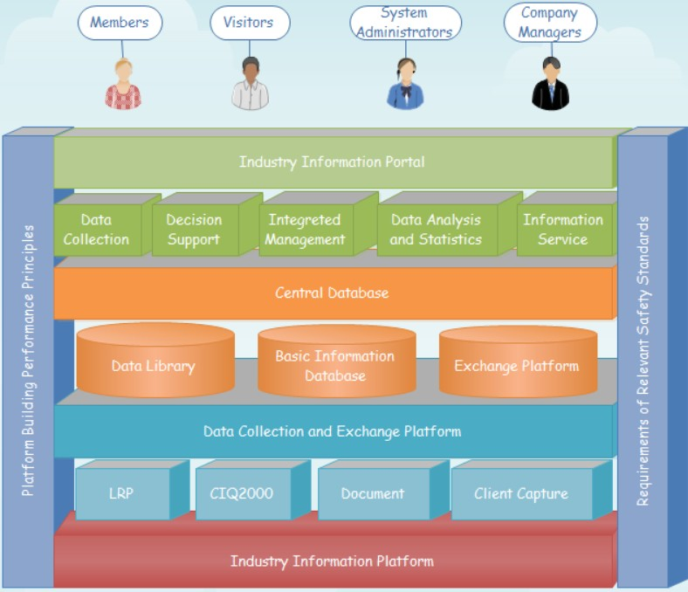

* + 1. **SYSTEM ARCHITECTURE**

A system architecture diagram is the distribution of the functional correspondences.

These are formal elements, the embodiment of concepts and information. Architecture defines the relations between elements, among features, and the surrounding elements. Creating an Architecture diagram is not easy.

##### USE CASE DIAGRAM

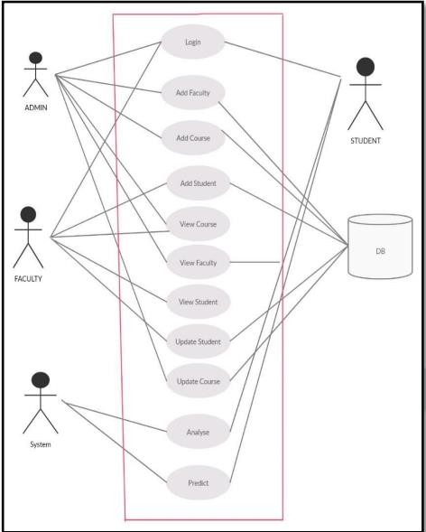

* + 1. **use case diagram**

The use case diagram are usually referred to as behavior diagram used to describe the actions of all user in a system. All user describe in use case are actors and the functionality as action of system.

The Use case diagram is a collection of diagram and text together that make action on goal of a process.

Use case diagram for student information system project. In Student information system there is a only one actor Admin can do all the activities to run the system.

##### CLASS DIAGRAM

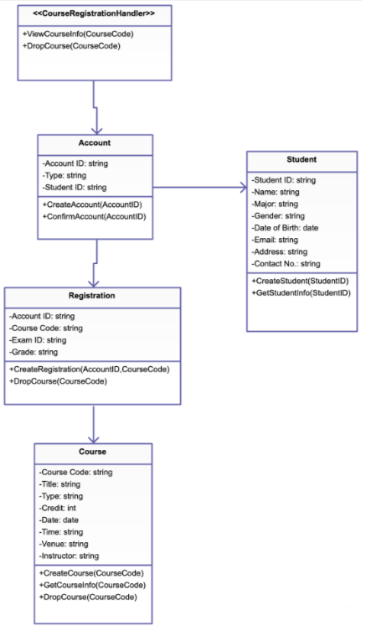

**Fig**. **6.3 class diagram**

Class diagram is a static diagram. It represents the static view of an application.

Class diagram is not only used for visualizing, describing, and documenting different aspects of a system but also for constructing executable code of the software application.

##### CHAPTER-7

**ENTITY RELATIONSHIP DIAGRAM**

To create the Entity Relationship Diagram for Secure Digital Authentication System

**Entity Relationship Diagram:-**

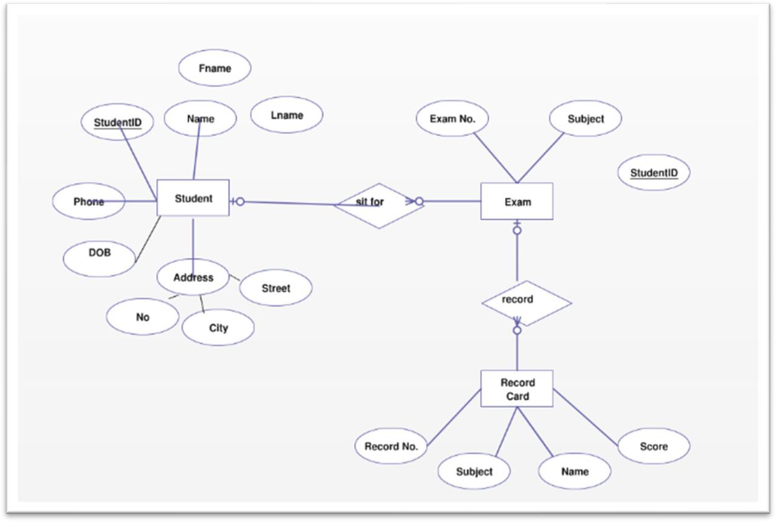

##### 7.1

The details of Student is store into the Student tables respective with all tables

Each entity (Exams, Logins, Cources, Fees, Student) contains primary key and unique keys. The entity Logins, Cources has binded with Student, Fees entities with foreign key

There is one-to-one and one-to-many relationships available between Cources, Profiles, Exams, Student

All the entities Student, Cources, Logins, Exams are normalized and reduce duplicacy of records . We have implemented indexing on each tables of Student Management System tables for fast query execution.

##### CHAPTER-8 DATA FLOW DIAGRAM

To develop the data flow diagram up to level 1 for the student performance details

* 1. **Data Flow Diagram-level 0**

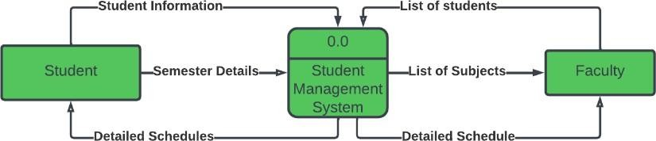

**8.1.1**

The 0 level dfd known as **context level** data flow diagram. The context level data flow diagram (dfd) is describe the whole system. The (o) level dfd describe the all user modules who run the system. Below context level data flow diagram of Student management system project shows the one Admin user can operate the system. Admin do all activities after login to system.

##### Data Flow Diagram-level 1

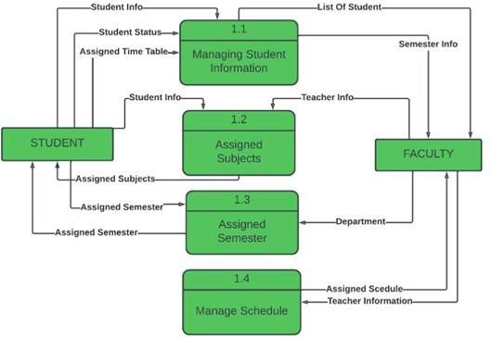

**Fig.8.2.1 DFD L-1**

The Admin side DFD describe the functionality of Admin. Admin is a responsible person who run the project. After login to system admin can first Add Course Detail and Teacher Detail and then add student detail by course wise. and admin can manage student reports and fees payment detail.

##### Data Flow Diagram-level 2

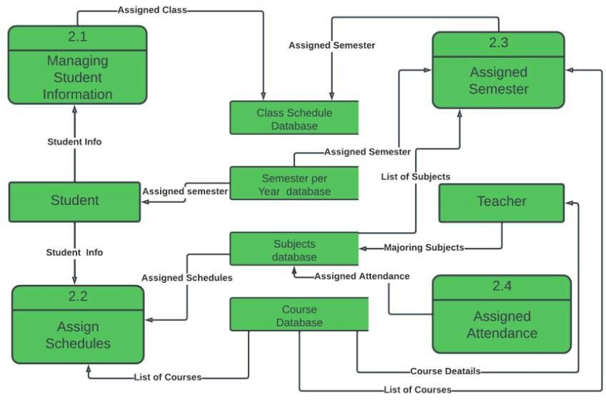

**Fig. 8.3.1 DFD L-2**

##### CHAPTER-9

**SEQUENCE & COLLABORATION DIAGRAM**

To create the sequence and collaboration diagram for the student performace details.

##### Sequence Diagram:-

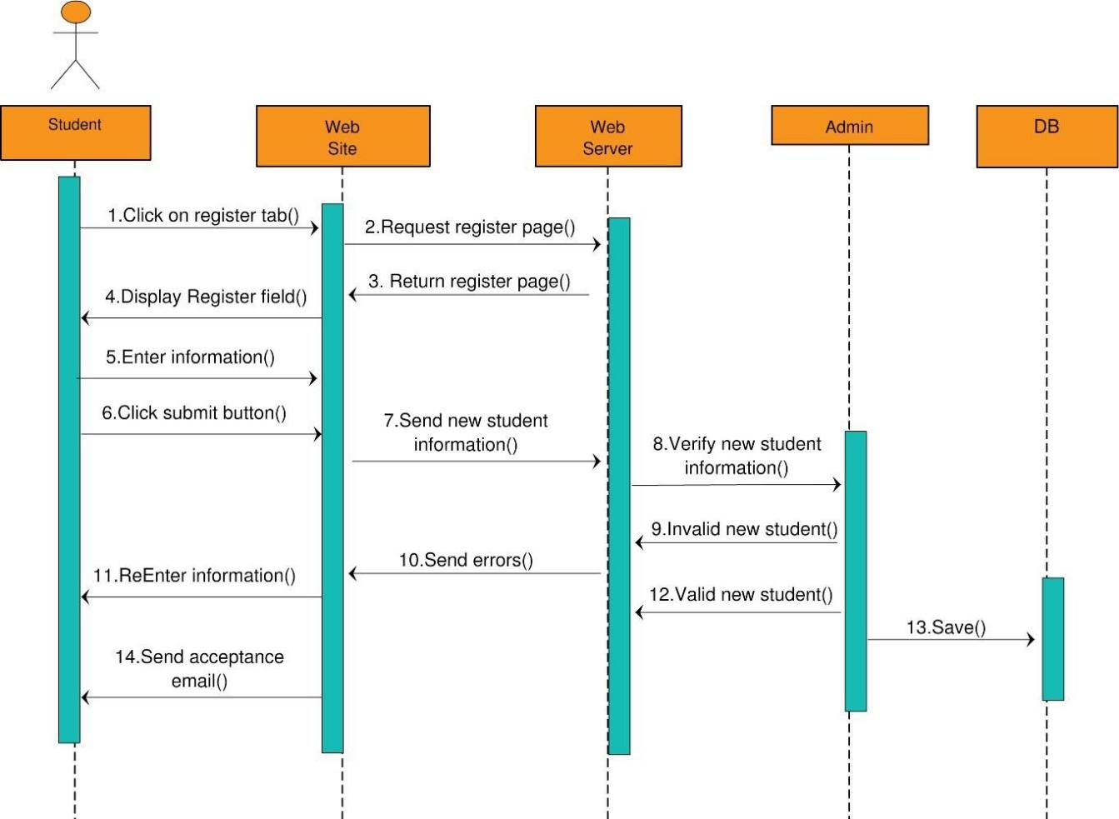

**Fig.9.1.1 sequence diagram**

The messages are shown and annotated to assist you in creating a College Management System. If you have further ideas, you can change the design. You can also expand on this design and use it as a blueprint for your project.

By drawing a sequence diagram, you will be able to comprehend and educate yourself on how the College Management System operates. Because it determines the objects, actors, and messages that are required, as well as their interactions.

By drawing a sequence diagram, you will be able to comprehend and comprehend how the System operates. It aids in the identification of required objects, actors, and messages, as well as their interactions.

##### collaboration diagram:-

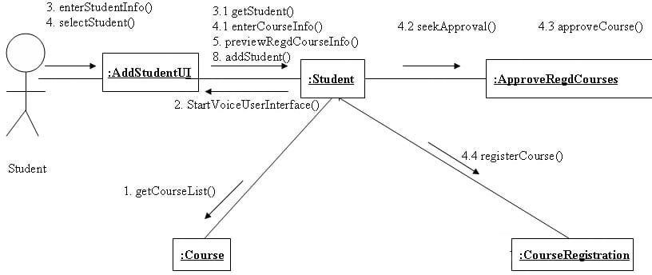

**Fig.9.2.1 collaboration diagram**

##### CHAPTER-10

**DEVELOPMENT OF TESTING FRAMEWORK/USER INTERFACE**

To develop the testing framework and/or user interface framework for the student performace details.

* 1. **TESTING INFO**

##### Functionality Testing

Test for – all the links in web pages, database connections, forms used for submitting or getting information from the user in the web pages, Cookie testing, etc.

Check out all the links:

* + - * Test the outgoing links from all the pages to the specific domain under test.
      * Test all internal links.
      * Test links jumping on the same page.
      * Test links are used to send emails to admin or other users from web pages.
      * Test to see if there are any orphan pages.
      * Finally, link checking includes, checking for broken links in all the above- mentioned links.

##### Usability Testing

Usability testing is the process by which the human-computer interaction characteristics of a system are measured, and weaknesses are identified for correction.

* Ease of learning
* Navigation
* Subjective user satisfaction
* General appearance

##### Interface Testing

In web testing, the server-side interface should be tested. This can be done by verifying that the communication is done properly. The compatibility of the server with software, hardware, network, and database should be tested.

The main interfaces are:

* + - * Web server and application server interface
      * Application server and Database server interface.

##### Compatibility Testing

The compatibility of your website is a very important testing aspect.

See which compatibility test to be executed:

* + - * Browser compatibility
      * Operating system compatibility
      * Mobile browsing
      * Printing options

##### Performance Testing

The web application should sustain a heavy load. Web performance testing should include:

* + - * Web Load Testing
      * Web Stress Testing

Test application performance at different internet connection speeds.

##### Security Testing

The primary reason for testing the security of a web is to identify potential vulnerabilities and subsequently repair them.

* + - * Network Scanning
      * Vulnerability Scanning
      * Password Cracking
      * Log Review
      * Integrity Checkers
      * Virus Detection

##### 10.2 USER INTERFACE:

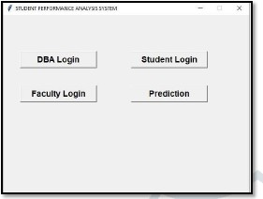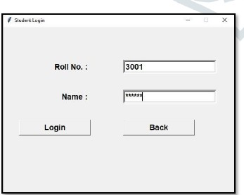

**Fig.10.2.1 home page Fig.10.2.2 login page**

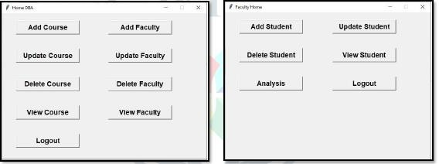

##### Fig.10.2.3 dba home

**CHAPTER-11**

##### TEST CASES & REPORTING

To develop the test cases manual for the student performace details..

##### 11.1 Functional Test Cases

|  |  |  |  |  |  |  |  |
| --- | --- | --- | --- | --- | --- | --- | --- |
| **Test ID**  **(#)** | **Test Scenario** | **Test Case** | **Execution Steps** | **Expected Outcome** | **Actual Outcome** | **Status** | **Rema rks** |
|  | Verify User Registratio n from India | Accept Valid India Mobile Number on the Page#1 | 1. User clicks on User Registrati on link 2. Enter the mobile Number on the text box 3. Click Register button | User should be taken to the next page for entering more user details | User should be taken to the next page for entering more user details | Pass / Failur e | succe ss |
|  | Verify User Registratio n from India | Don’t Accept Non IndianMobi le Number on the Page#1 | 1.clicks on the register link 2.enters invalid number 3.click  register | User is promted defining the error occured | Promted back error specified | Pass / Failur e | failur e |
|  | Fully privileged user can make account changes | Full Privileged only can make changes | 1. User enters the userid and password 2. User sees edit permissions to modify account itself 3. User modifies account information and saves. 4. User logs out. | 1. User is logged into the home page 2. Edit screen is presented to the user. 3. Account information is saved 4. User is taken back to login   page | 1. User is logged into the home page 2. Edit screen is presented to the user. 3. Account information is saved 4. User is taken back to login page | Pass / Failur e | pass |

|  |  |  |  |  |  |  |  |
| --- | --- | --- | --- | --- | --- | --- | --- |
|  | Another valid user without full privileges | Permitted to less changes to without full privilege | 1. User enters the userid and password 2. User sees edit permissions to modify only certain fields. 3. User modifies only those fields and saves. 4. User logs out. | 1. User is logged into the home page 2. Edit screen is presented to the user only on certain fields. The account fields are grayed out. 3. Fields modified are saved 4. User is taken back to login page | 1. User is logged into the home page 2. Edit screen is presented to the user only on certain fields. The account fields are grayed out. 3. Fields modified are saved 4. User is taken back to login page | Pass / Failur e | pass |

**CHAPTER-12 ARCHITECTURE/DESIGN/FRAMEWORK/IMPLE-MENTATION**

To provide the details of architectural design/framework/implementation. Thus, the details of architectural design/framework/implementation along with the screen shots were provided.

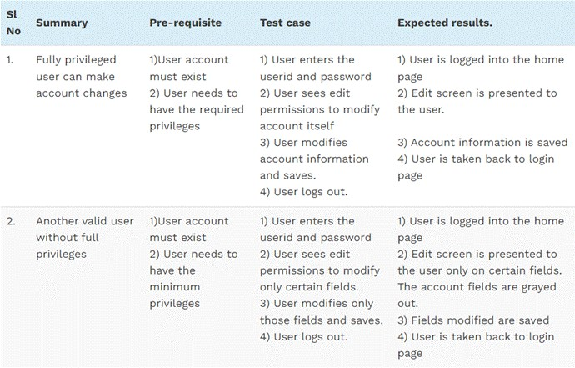

**Fig.12.1**

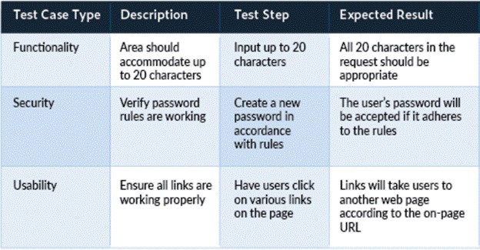

**Fig.12.2**

##### current status of the Testing

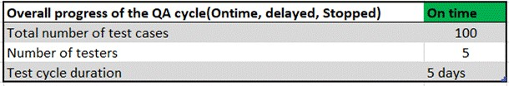

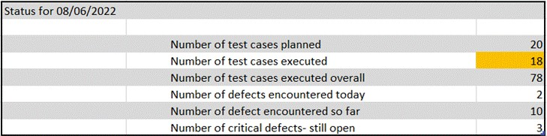

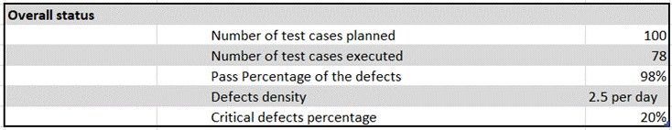

* 1. **present obstacles to proceed further**
     + City you clear goals and objectives.
     + Scope creep.
     + Budget restrictions and changes.
     + Lack of communication.
     + Team conflict.
     + Mismatched team skills.
     + Absence of accountability.
     + Impractical deadlines.

##### Seek help from stakeholders to remove obstacles

* + - [Set out the goals clearly](https://www.teamwork.com/templates/business-goals/) and ensure buy-in from all stakeholders
    - Poor planning can only lead to project failure or delays and cost overruns. It will also infuriate all stakeholders.
    - For the project manager, this presents a host of problems that need to be addressed, ranging from planning for the new situation and strategizing for a solution that entails minimal inconvenience for stakeholders.
    - Assessing your stakeholder's interests also provides a strong basis for legal compliance, enabling you to put protocols in place that protect the privacy of stakeholders.
    - By developing a deep understanding of your project stakeholders, project managers can create sound plans to eliminate delays, mitigate risks, and better align projects with wider business goals.

|  |  |  |
| --- | --- | --- |
| Category | Progress Against Plan | Status |
| Functional Testing | amber | Still in progress |
| Non-Functional Testing | green | completed |

|  |  |  |
| --- | --- | --- |
| Functional | Test Case Coverage  (%) | Status |
| 73196 | 60% | In progress |
| 3197 | 100% | completed |
| 3198 | 100% | completed |
| 3199 | 100% | completed |

##### Exp-13

##### Architectural design/framework

##### 13.1

##### 

Fig.13.2.1 student login page

**13.2**

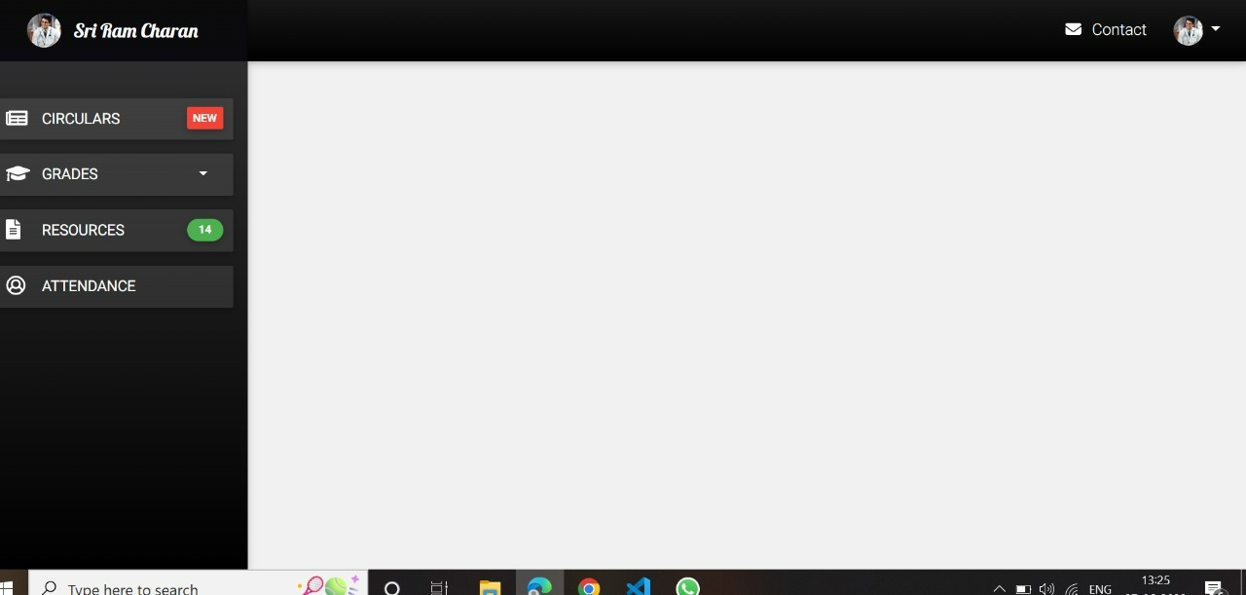

Fig.13.3.1 home page

Pseudocode login

1. Start
2. Enter User Name
3. Enter Password
4. If User Name== Null

Then Display “User Name cannot be Empty” Else If Username! = Null

Then Check if User Name is in Database and Valid.

1. If Password==NULL

Then Display “Password cannot be Null” Else if Password! =NULL

Then Check if User Name and Respect password in Database are Equal If entered Password == Respective Password in Database

Then Open Home Page on Clicking Login and Display “Login Successful”.

1. If Username not present in database Then Display “Not a Registered User”.
2. Stop.x

**CODE:**

<!DOCTYPE html>

<html lang="en">

<head>

<meta charset="UTF-8">

<meta name="viewport" content="width=device-width, initial-scale=1.0">

<meta http-equiv="X-UA-Compatible" content="ie=edge">

<title>Student | Dashboard</title>

<!-- Normalize browser inconsistencies -->

<link rel="stylesheet" href="./css/normalize.css">

<!-- Bootstrap -->

<link rel="stylesheet" href="./css/bootstrap.min.css">

<!-- Font Awesome -->

<script defer src="./js/fontawesome-all.min.js"></script>

<!-- MD Bootstrap -->

<link rel="stylesheet" href="./css/mdb.min.css">

<!-- Custom stylesheet -->

<link rel="stylesheet" href="./css/styles.css">

<style>

/* Scrollbar styling */

body::-webkit-scrollbar {

width: 9px;

}

body::-webkit-scrollbar-thumb {

border-radius: 10px;

background-color: rgba(29, 17, 17, 0.788);

}

body::-webkit-scrollbar-track {

background-color: rgb(230, 223, 223);

border-radius: 10px;

}

/* Profile Modal */

.card.profile-card {

width: 100%;

margin: 0;

}

#profileModal .modal-content,

#profileModal .modal-content .modal-body,

#profileModal .modal-content .modal-body .card.profile-card {

border-radius: 10px;

}

#profileModal .modal-content .modal-body .card.profile-card img {

border-radius: 10px 10px 0 0;

}

</style>

</head>

<body>

<!-- Wrapper stretches to the whole viewport height -->

<div class="wrapper">

<!-- Sidebar -->

<nav id="sidebar" class="navbar sticky-top">

<div class="navbar-header">

<img src="./img/drake-ramoray.jpg" class="rounded-circle" alt="Profile picture">

<h5 class="navbar-brand m-1 text-white pl-2">Sri Ram Charan </h5>

</div>

<!-- Navbar links -->

<ul class="navbar-nav">

<li class="nav-item active">

<a href="./index.html" class="nav-link btn btn-block btn-lg">

<i class="fas fa-newspaper fa-lg mr-1"></i>

<span>Circulars</span>

<span class="badge red d-flex align-items-center justify-content-center">New</span>

</a>

</li>

<li class="nav-item btn-group">

<a href="#" class="nav-link btn btn-block btn-lg dropdown-toggle" role="button" data-toggle="dropdown" aria-haspopup="true" aria-expanded="false">

<i class="fas fa-graduation-cap fa-lg mr-1"></i>

<span>Grades</span>

</a>

<ul id="marks" class="dropdown dropdown-menu">

<li>

<a href="./grades-sem-1.html" class="nav-link dropdown-item">Semester 1</a>

</li>

<li>

<a href="./grades-sem-2.html" class="nav-link dropdown-item">Semester 2</a>

</li>

<li>

<a href="./grades-sem-3.html" class="nav-link dropdown-item">Semester 3</a>

</li>

<li>

<a href="./grades-sem-4.html" class="nav-link dropdown-item">Semester 4</a>

</li>

</ul>

</li>

<li class="nav-item">

<a href="./resources.html" class="nav-link btn btn-block btn-lg">

<i class="fas fa-file-alt fa-lg mr-1"></i>

<span>Resources</span>

<span class="badge badge-pill green d-flex align-items-center justify-content-center">14</span>

</a>

</li>

<li class="nav-item">

<a href="./attendance.html" class="nav-link btn btn-block btn-lg">

<i class="far fa-user-circle fa-lg mr-1"></i>

<span>Attendance</span>

</a>

</li>

</ul>

</nav>

<!-- Main -->

<main>

<!-- Topbar -->

<nav id="topbar" class="navbar navbar-expand-md sticky-top">

<!-- sidebar toggle button -->

<button id="topbar-toggler" class="navbar-toggler" type="button" data-toggle="collapse">

<span class="fas fa-align-left"></span>

</button>

<!-- topbar items toggle button -->

<button class="navbar-toggler collapsed" type="button" data-toggle="collapse" data-target="#topbar-items">

<span class="fas fa-ellipsis-v"></span>

</button>

<!-- topbar items -->

<div class="navbar-collapse collapse" id="topbar-items">

<ul class="navbar-nav ml-auto">

<li class="nav-item">

<a class="nav-link waves-effect waves-light" href="#">

<i class="fa fa-envelope"></i>

<span>Contact</span>

</a>

</li>

<li class="nav-item dropdown">

<a class="nav-link waves-effect waves-light dropdown-toggle" id="dropdown-items" data-toggle="dropdown">

<img src="img/drake-ramoray.jpg" class="rounded-circle" alt="profile picture">

</a>

<div class="dropdown-menu dropdown-menu-right dropdown-menu-secondary">

<a class="dropdown-item waves-effect waves-light" href="#">Profile</a>

<a class="dropdown-item waves-effect waves-light" href="#">Feedback</a>

<a class="dropdown-item waves-effect waves-light" href="#">Log Out</a>

</div>

</li>

</ul>

</div>

</nav>

<!-- Emma Stone Award Modal

<article class="modal fade" id="emmaModal" tab-index="-1" aria-hidden="true">

<section class="modal-dialog modal-lg">

<section class="modal-content">

<--Modal Head -->

<!-- Modal Footer -->

</section>

</section>

</article>

<!-- Modal for video -->

<article class="modal fade" id="modalNorway" tabindex="-1" aria-hidden="true">

<section class="modal-dialog modal-lg">

<section class="modal-content">

<!-- Body -->

<section class="modal-body mb-0 p-0">

<div class="embed-responsive embed-responsive-16by9 z-depth-1-half">

<iframe class="embed-responsive-item" src="https://www.youtube.com/embed/YJPgoOCOBFg" allowfullscreen></iframe>

</div>

</section>

<!-- Footer -->

<section class="modal-footer justify-content-center flex-column flex-md-row">

<span class="mr-4">JK. Lalu sir is too cool for that. Look at those mountains though!</span>

<button class="btn btn-outline-primary btn-rounded btn-md ml-4" data-dismiss="modal">Close</button>

</section>

</section>

</section>

</article>

</div>

</main>

</div>

<!-- Bootstrap dependencies -->

<!-- First jQuery, then Popper.js and lastly Bootstrap JS -->

<script src="js/jquery-3.3.1.min.js"></script>

<script src="https://cdnjs.cloudflare.com/ajax/libs/popper.js/1.12.9/umd/popper.min.js" integrity="sha384-ApNbgh9B+Y1QKtv3Rn7W3mgPxhU9K/ScQsAP7hUibX39j7fakFPskvXusvfa0b4Q" crossorigin="anonymous"></script>

<script src="https://maxcdn.bootstrapcdn.com/bootstrap/4.0.0/js/bootstrap.min.js" integrity="sha384-JZR6Spejh4U02d8jOt6vLEHfe/JQGiRRSQQxSfFWpi1MquVdAyjUar5+76PVCmYl" crossorigin="anonymous"></script>

<script src="js/mdb.min.js"></script>

<!-- Custom script -->

<script src="./js/scripts.js"></script>

</body>

</html>

**Resource page:**

<!DOCTYPE html>

<html lang="en">

<head>

<meta charset="UTF-8">

<meta name="viewport" content="width=device-width, initial-scale=1.0">

<meta http-equiv="X-UA-Compatible" content="ie=edge">

<title>Student | Dashboard</title>

<!-- Normalize browser inconsistencies -->

<link rel="stylesheet" href="./css/normalize.css">

<!-- Bootstrap -->

<link rel="stylesheet" href="./css/bootstrap.min.css">

<!-- Font Awesome -->

<script defer src="./js/fontawesome-all.min.js"></script>

<!-- MD Bootstrap -->

<link rel="stylesheet" href="./css/mdb.min.css">

<!-- Custom stylesheet -->

<link rel="stylesheet" href="./css/styles.css">

<style>

.content .card {

width: 80%;

}

.content .card .card-deck .card {

width: 100%;

}

@media screen and (max-width: 575px) {

.content .card {

width: 90%;

min-width: 0;

}

}

/* Scrollbar styling */

body::-webkit-scrollbar {

width: 9px;

}

body::-webkit-scrollbar-thumb {

border-radius: 10px;

background-color: rgb(2, 175, 175);

}

body::-webkit-scrollbar-track {

background-color: rgb(230, 223, 223);

border-radius: 10px;

}

</style>

</head>

<body>

<!-- Wrapper stretches to the whole viewport height -->

<div class="wrapper">

<!-- Sidebar -->

<nav id="sidebar" class="navbar sticky-top">

<div class="navbar-header">

<img src="./img/drake-ramoray.jpg" class="rounded-circle" alt="Profile picture">

<h5 class="navbar-brand m-1 text-white pl-2">Sriramcharan</h5>

</div>

<!-- Navbar links -->

<ul class="navbar-nav">

<li class="nav-item active">

<a href="./index.html" class="nav-link btn btn-block btn-lg">

<i class="fas fa-newspaper fa-lg mr-1"></i>

<span>Circulars</span>

<span class="badge red d-flex align-items-center justify-content-center">New</span>

</a>

</li>

<li class="nav-item btn-group">

<a href="#" class="nav-link btn btn-block btn-lg dropdown-toggle" role="button" data-toggle="dropdown" aria-haspopup="true" aria-expanded="false">

<i class="fas fa-graduation-cap fa-lg mr-1"></i>

<span>Grades</span>

</a>

<ul id="marks" class="dropdown-menu">

<li>

<a href="./grades-sem-1.html" class="nav-link dropdown-item">Semester 1</a>

</li>

<li>

<a href="./grades-sem-2.html" class="nav-link dropdown-item">Semester 2</a>

</li>

<li>

<a href="./grades-sem-3.html" class="nav-link dropdown-item">Semester 3</a>

</li>

<li>

<a href="./grades-sem-4.html" class="nav-link dropdown-item">Semester 4</a>

</li>

</ul>

</li>

<li class="nav-item">

<a href="./resources.html" class="nav-link btn btn-block btn-lg">

<i class="fas fa-file-alt fa-lg mr-1"></i>

<span>Resources</span>

<span class="badge badge-pill green d-flex align-items-center justify-content-center">14</span>

</a>

</li>

<li class="nav-item">

<a href="./attendance.html" class="nav-link btn btn-block btn-lg">

<i class="far fa-user-circle fa-lg mr-1"></i>

<span>Attendance</span>

</a>

</li>

</ul>

</nav>

<!-- Main -->

<main>

<!-- Topbar -->

<nav id="topbar" class="navbar navbar-expand-md sticky-top">

<!-- sidebar toggle button -->

<button id="topbar-toggler" class="navbar-toggler" type="button" data-toggle="collapse">

<span class="fas fa-align-left"></span>

</button>

<!-- topbar items toggle button -->

<button class="navbar-toggler collapsed" type="button" data-toggle="collapse" data-target="#topbar-items">

<span class="fas fa-ellipsis-v"></span>

</button>

<!-- topbar items -->

<div class="navbar-collapse collapse" id="topbar-items">

<ul class="navbar-nav ml-auto">

<li class="nav-item">

<a class="nav-link waves-effect waves-light" href="#">

<i class="fa fa-envelope"></i>

<span>Contact</span>

</a>

</li>

<li class="nav-item dropdown">

<a class="nav-link waves-effect waves-light dropdown-toggle" id="dropdown-items" data-toggle="dropdown">

<img src="img/drake-ramoray.jpg" class="rounded-circle" alt="profile picture">

</a>

<div class="dropdown-menu dropdown-menu-right dropdown-menu-secondary">

<a class="dropdown-item waves-effect waves-light" href="#">Profile</a>

<a class="dropdown-item waves-effect waves-light" href="#">Feedback</a>

<a class="dropdown-item waves-effect waves-light" href="#">Log Out</a>

</div>

</li>

</ul>

</div>

</nav>

<!-- Content -->

<div class="content">

<!-- First subject card -->

<article class="card card-cascade wider">

<section class="view gradient-card-header purple-gradient overlay d-flex align-items-center justify-content-center pt-2 pb-2">

<h4 class="card-header">Andrew Nag</h4>

</section>

<section class="card-body">

<!-- First card deck -->

<section class="card-deck">

<section class="card">

<section class="view overlay p-3 text-center">

<h6 class="indigo-text darken-4">

<i class="fas fa-sticky-note"></i> Notes

</h6>

<p class="card-text">Machine Learning</p>

<a class="btn btn-indigo" role="button" target="_blank">Download</a>

</section>

</section>

<section class="card">

<section class="view overlay p-3 text-center">

<h6 class="indigo-text darken-4">

<i class="fas fa-sticky-note"></i> Notes

</h6>

<p class="card-text">INtroduction to AI</p>

<a class="btn btn-indigo" role="button" target="_blank">Download</a>

</section>

</section>

</section>

</section>

</article>

<!-- Second subject card -->

<article class="card card-cascade wider">

<section class="view gradient-card-header peach-gradient overlay d-flex align-items-center justify-content-center pt-2 pb-2">

<img src="./img/teachers/lalu.jpeg" class="rounded-circle" alt="Profile picture" height="60px" width="60px">

<h4 class="card-header">Lalu Prasad</h4>

</section>

<section class="card-body">

<section class="card-deck">

<section class="card">

<section class="view overlay p-3 text-center">

<h6 class="red-text darken-4">

<i class="fab fa-youtube"></i> Video

</h6>

<p class="card-text">Introduction to python</p>

<a class="btn btn-danger" role="button" target="_blank">Watch video</a>

</section>

</section>

<section class="card">

<section class="view overlay p-3 text-center">

<h6 class="indigo-text darken-4">

<i class="fas fa-sticky-note"></i> Notes

</h6>

<p class="card-text">Introduction to python</p>

<a class="btn btn-indigo" role="button" target="_blank">Download</a>

</section>

</section>

<section class="card">

<section class="view overlay p-3 text-center">

<h6 class="darken-4">

<i class="fas fa-book"></i> Book

</h6>

<p class="card-text">Anand Kumar Book</p>

<a class="btn btn-elegant" role="button" target="_blank">Download illegal pdf</a>

</section>

</section>

<section class="card">

<section class="view overlay p-3 text-center">

<h6 class="pink-text darken-4">

<i class="fas fa-file-alt"></i> Assignment

</h6>

<p class="card-text">Assignments</p>

<a class="btn btn-unique" role="button" target="_blank">Download assignment</a>

</section>

</section>

<section class="card">

<section class="view overlay p-3 text-center">

<h6 class="red-text darken-4">

<i class="fab fa-youtube"></i> Video

</h6>

<p class="card-text">robotics</p>

<a class="btn btn-danger" role="button" target="_blank">Watch video</a>

</section>

</section>

<section class="card">

<section class="view overlay p-3 text-center">

<h6 class="deep-orange-text darken-4">

<i class="fas fa-file-powerpoint"></i> Powerpoint Presentation

</h6>

<p class="card-text">python</p>

<a class="btn btn-deep-orange" role="button" target="_blank">Download ppt</a>

</section>

</section>

</section>

</section>

</article>

<!-- Ross Geller's card -->

<article class="card card-cascade wider">

<section class="view gradient-card-header aqua-gradient overlay d-flex align-items-center justify-content-center pt-2 pb-2">

<img src="./img/teachers/ross-geller.jpg" class="rounded-circle" alt="Profile picture" height="60px" width="60px">

<h4 class="card-header">Sriramcharan</h4>

</section>

<section class="card-body">

<section class="card-deck">

<section class="card">

<section class="view overlay p-3 text-center">

<h6 class="darken-4">

<i class="fas fa-book"></i> Book

</h6>

<p class="card-text">Prehistoric life</p>

<a href="https://www.amazon.in/Prehistoric-Life-Definitive-Visual-History/dp/075669910X" class="btn btn-elegant" role="button" target="_blank">Buy book</a>

</section>

</section>

<section class="card">

<section class="view overlay p-3 text-center">

<h6 class="deep-purple-text darken-4">

<i class="far fa-newspaper"></i> Article

</h6>

<p class="card-text">Best places to see fossils</p>

<a href="https://www.smithsonianmag.com/travel/travel-through-time-national-fossil-day-180952992/" class="btn btn-deep-purple" role="button" target="_blank">View article</a>

</section>

</section>

<section class="card">

<section class="view overlay p-3 text-center">

<h6 class="red-text darken-4">

<i class="fab fa-youtube"></i> Video

</h6>

<p class="card-text">Unagi</p>

<a href="https://www.youtube.com/watch?v=jbRVoTL5djs" class="btn btn-danger" role="button" target="_blank">Watch video</a>

</section>

</section>

<section class="card">

<section class="view overlay p-3 text-center">

<h6 class="red-text darken-4">

<i class="fab fa-youtube"></i> Video

</h6>

<p class="card-text">Artificial gas in gas cylinders</p>

<a href="https://www.youtube.com/watch?v=k7lKAKopkf4" class="btn btn-danger" role="button" target="_blank">Watch video</a>

</section>

</section>

<section class="card">

<section class="view overlay p-3 text-center">

<h6 class="deep-purple-text darken-4">

<i class="far fa-newspaper"></i> Article

</h6>

<p class="card-text">A successful marriage</p>

<a href="https://www.becomingminimalist.com/8-essentials-for-a-successful-marriage/" class="btn btn-deep-purple" role="button" target="_blank">View article</a>

</section>

</section>

</section>

</section>

</article>

<!-- Third subject card -->

<article class="card card-cascade wider">

<section class="view gradient-card-header blue-gradient overlay d-flex align-items-center justify-content-center pt-2 pb-2">

<img src="./img/teachers/alexandra.jpeg" class="rounded-circle" alt="Profile picture" height="60px" width="60px">

<h4 class="card-header">Richard Roise</h4>

</section>

<section class="card-body">

<section class="card-deck">

<section class="card">

<section class="view overlay p-3 text-center">

<h6 class="deep-orange-text darken-4">

<i class="fas fa-file-powerpoint"></i> Powerpoint Presentation

</h6>

<p class="card-text">OODP</p>

<a class="btn btn-deep-orange" role="button" target="_blank">Download ppt</a>

</section>

</section>

<section class="card">

<section class="view overlay p-3 text-center">

<h6 class="darken-4">

<i class="fas fa-book"></i> Book

</h6>

<p class="card-text">Object oriented Design and programming</p>

<a class="btn btn-elegant" role="button" target="_blank">Download pdf</a>

</section>

</section>

<section class="card">

<section class="view overlay p-3 text-center">

<h6 class="indigo-text darken-4">

<i class="fas fa-sticky-note"></i> Notes

</h6>

<p class="card-text">Short notes</p>

<a class="btn btn-indigo" role="button" target="_blank">Download</a>

</section>

</section>

</section>

</section>

</article>

<!-- Bootstrap dependencies -->

<!-- First jQuery, then Popper.js and lastly Bootstrap JS -->

<script src="js/jquery-3.3.1.min.js"></script>

<script src="https://cdnjs.cloudflare.com/ajax/libs/popper.js/1.12.9/umd/popper.min.js" integrity="sha384-ApNbgh9B+Y1QKtv3Rn7W3mgPxhU9K/ScQsAP7hUibX39j7fakFPskvXusvfa0b4Q" crossorigin="anonymous"></script>

<script src="https://maxcdn.bootstrapcdn.com/bootstrap/4.0.0/js/bootstrap.min.js" integrity="sha384-JZR6Spejh4U02d8jOt6vLEHfe/JQGiRRSQQxSfFWpi1MquVdAyjUar5+76PVCmYl" crossorigin="anonymous"></script>

<script src="js/mdb.min.js"></script>

<!-- Custom script -->

<script src="./js/scripts.js"></script>

</body>

</html>

**Attendence :**

<!DOCTYPE html>

<html lang="en">

<head>

<meta charset="UTF-8">

<meta name="viewport" content="width=device-width, initial-scale=1.0">

<meta http-equiv="X-UA-Compatible" content="ie=edge">

<title>Student | Dashboard</title>

<!-- Normalize browser inconsistencies -->

<link rel="stylesheet" href="./css/normalize.css">

<!-- Bootstrap -->

<link rel="stylesheet" href="./css/bootstrap.min.css">

<!-- Font Awesome -->

<script defer src="./js/fontawesome-all.min.js"></script>

<!-- MD Bootstrap -->

<link rel="stylesheet" href="./css/mdb.min.css">

<!-- Custom stylesheet -->

<link rel="stylesheet" href="./css/styles.css">

<style>

.content .card {

min-width: 900px;

width: 85%;

}

/* Scrollbar styling */

body::-webkit-scrollbar {

width: 9px;

}

body::-webkit-scrollbar-thumb {

border-radius: 10px;

background-image: linear-gradient(40deg, #59c0e6, #0f1435);

}

body::-webkit-scrollbar-track {

background-color: rgb(230, 223, 223);

border-radius: 10px;

}

</style>

</head>

<body>

<!-- Wrapper stretches to the whole viewport height -->

<div class="wrapper">

<!-- Sidebar -->

<nav id="sidebar" class="navbar sticky-top">

<div class="navbar-header">

<img src="./img/drake-ramoray.jpg" class="rounded-circle" alt="Profile picture">

<h5 class="navbar-brand m-1 text-white pl-2">SriRamCharan</h5>

</div>

<!-- Navbar links -->

<ul class="navbar-nav">

<li class="nav-item active">

<a href="./index.html" class="nav-link btn btn-block btn-lg">

<i class="fas fa-newspaper fa-lg mr-1"></i>

<span>Circulars</span>

<span class="badge red d-flex align-items-center justify-content-center">New</span>

</a>

</li>

<li class="nav-item btn-group">

<a href="#" class="nav-link btn btn-block btn-lg dropdown-toggle" role="button" data-toggle="dropdown" aria-haspopup="true" aria-expanded="false">

<i class="fas fa-graduation-cap fa-lg mr-1"></i>

<span>Grades</span>

</a>

<ul id="marks" class="dropdown-menu">

<li>

<a href="./grades-sem-1.html" class="nav-link dropdown-item">Semester 1</a>

</li>

<li>

<a href="./grades-sem-2.html" class="nav-link dropdown-item">Semester 2</a>

</li>

<li>

<a href="./grades-sem-3.html" class="nav-link dropdown-item">Semester 3</a>

</li>

<li>

<a href="./grades-sem-4.html" class="nav-link dropdown-item">Semester 4</a>

</li>

</ul>

</li>

<li class="nav-item">

<a href="./resources.html" class="nav-link btn btn-block btn-lg">

<i class="fas fa-file-alt fa-lg mr-1"></i>

<span>Resources</span>

<span class="badge badge-pill green d-flex align-items-center justify-content-center">14</span>

</a>

</li>

<li class="nav-item">

<a href="./attendance.html" class="nav-link btn btn-block btn-lg">

<i class="far fa-user-circle fa-lg mr-1"></i>

<span>Attendance</span>

</a>

</li>

</ul>

</nav>

<!-- Main -->

<main>

<!-- Topbar -->

<nav id="topbar" class="navbar navbar-expand-md sticky-top">

<!-- sidebar toggle button -->

<button id="topbar-toggler" class="navbar-toggler" type="button" data-toggle="collapse">

<span class="fas fa-align-left"></span>

</button>

<!-- topbar items toggle button -->

<button class="navbar-toggler collapsed" type="button" data-toggle="collapse" data-target="#topbar-items">

<span class="fas fa-ellipsis-v"></span>

</button>

<!-- topbar items -->

<div class="navbar-collapse collapse" id="topbar-items">

<ul class="navbar-nav ml-auto">

<li class="nav-item">

<a class="nav-link waves-effect waves-light" href="#">

<i class="fa fa-envelope"></i>

<span>Contact</span>

</a>

</li>

<li class="nav-item dropdown">

<a class="nav-link waves-effect waves-light dropdown-toggle" id="dropdown-items" data-toggle="dropdown">

<img src="img/drake-ramoray.jpg" class="rounded-circle" alt="profile picture">

</a>

<div class="dropdown-menu dropdown-menu-right dropdown-menu-secondary">

<a class="dropdown-item waves-effect waves-light" href="#">Profile</a>

<a class="dropdown-item waves-effect waves-light" href="#">Feedback</a>

<a class="dropdown-item waves-effect waves-light" href="#">Log Out</a>

</div>

</li>

</ul>

</div>

</nav>

<!-- Content -->

<div class="content">

<!-- Card -->

<article class="card card-cascade narrower">

<!-- Card heading -->

<section class="view gradient-card-header blue-gradient narrower py-2 mx-4 mb-3 d-flex justify-content-center align-items-center">

<span class="white-text mx-3">Attendance</span>

</section>

<!-- Card content -->

<section class="px-4">

<!-- Table -->

<section class="table-wrapper">

<table class="table table-hover mb-0">

<thead>

<tr>

<th class="th-md">

<a href="">Subject Code

<i class="fa fa-sort ml-1"></i>

</a>

</th>

<th class="th-md">

<a href="">Subject Name

<i class="fa fa-sort ml-1"></i>

</a>

</th>

<th class="th-md">

<a href="">Teacher

<i class="fa fa-sort ml-1"></i>

</a>

</th>

<th class="th-md">

<a href="">From

<i class="fa fa-sort ml-1"></i>

</a>

</th>

<th class="th-md">

<a href="">To

<i class="fa fa-sort ml-1"></i>

</a>

</th>

<th class="th-md">

<a href="">Attended

<i class="fa fa-sort ml-1"></i>

</a>

</th>

<th class="th-md">

<a href="">DL

<i class="fa fa-sort ml-1"></i>

</a>

</th>

<th class="th-md">

<a href="">ML

<i class="fa fa-sort ml-1"></i>

</a>

</th>

<th class="th-md">

<a href="">Delivered

<i class="fa fa-sort ml-1"></i>

</a>

</th>

<th class="th-md">

<a href="">%age

<i class="fa fa-sort ml-1"></i>

</a>

</th>

<th class="th-md">

<a href="">Total approved DL

<i class="fa fa-sort ml-1"></i>

</a>

</th>

</tr>

</thead>

<tbody>

<tr>

<td>MAL5101</td>

<td>Mathematics</td>

<td>Alexandra Daddario</td>

<td>08-Aug-2020</td>

<td>31-Mar-2020</td>

<td>45</td>

<td>0</td>

<td>0</td>

<td>50</td>

<td class="percentage">90.00</td>

<td>0</td>

</tr>

<tr>

<td>SCSL3929</td>

<td>Semicondutor physics</td>

<td>Snoop Dogg</td>

<td>08-Aug-2020</td>

<td>31-Mar-2020</td>

<td>28</td>

<td>3</td>

<td>2</td>

<td>48</td>

<td class="percentage">68.75</td>

<td>3</td>

</tr>

<tr>

<td>PHD5892</td>

<td>BEEE

</td>

<td>Lalu Prasad Yadav</td>

<td>08-Aug-2020</td>

<td>31-Mar-2020</td>

<td>5</td>

<td>10</td>

<td>10</td>

<td>60</td>

<td class="percentage">41.67</td>

<td>10</td>

</tr>

<tr>

<td>BG3814</td>

<td>Biology</td>

<td>Cheshta Sharma</td>

<td>08-Aug-2020</td>

<td>31-Mar-2020</td>

<td>33</td>

<td>0</td>

<td>0</td>

<td>40</td>

<td class="percentage">82.5</td>

<td>0</td>

</tr>

<tr>

<td>ECE3859</td>

<td>Digital Electronics &amp; Logic Design</td>

<td>Emma Stone</td>

<td>08-Aug-2020</td>

<td>31-Mar-2020</td>

<td>74</td>

<td>0</td>

<td>0</td>

<td>74</td>

<td class="percentage">100.00</td>

<td>0</td>

</tr>

</tbody>

</table>

</section>

<hr class="my-0">

<!-- Semester page links -->

<nav class="my-4">

<ul class="pagination pagination-circle pg-blue mb-0">

<li class="page-item disabled">

<a class="page-link">Next</a>

</li>

<li class="page-item disabled">

<a class="page-link" aria-label="Next">

<span aria-hidden="true">&laquo;</span>

<span class="sr-only">Next</span>

</a>

</li>

<!-- Semester numbers -->

<li class="page-item active">

<a class="page-link">4</a>

</li>

<li class="page-item">

<a class="page-link">3</a>

</li>

<li class="page-item">

<a class="page-link">2</a>

</li>

<li class="page-item">

<a class="page-link">1</a>

</li>

<!-- Right Arrow -->

<li class="page-item">

<a class="page-link" aria-label="Previous">

<span aria-hidden="true">&raquo;</span>

<span class="sr-only">Previous</span>

</a>

</li>

<li class="page-item">

<a class="page-link">Previous</a>

</li>

</ul>

</nav>

</section>

</article>

</div>

</main>

</div>

<!-- Bootstrap dependencies -->

<!-- First jQuery, then Popper.js and lastly Bootstrap JS -->

<script src="js/jquery-3.3.1.min.js"></script>

<script src="https://cdnjs.cloudflare.com/ajax/libs/popper.js/1.12.9/umd/popper.min.js" integrity="sha384-ApNbgh9B+Y1QKtv3Rn7W3mgPxhU9K/ScQsAP7hUibX39j7fakFPskvXusvfa0b4Q" crossorigin="anonymous"></script>

<script src="https://maxcdn.bootstrapcdn.com/bootstrap/4.0.0/js/bootstrap.min.js" integrity="sha384-JZR6Spejh4U02d8jOt6vLEHfe/JQGiRRSQQxSfFWpi1MquVdAyjUar5+76PVCmYl" crossorigin="anonymous"></script>

<script src="js/mdb.min.js"></script>

<!-- Custom script -->

<script src="./js/scripts.js"></script>

<script>

$('table tbody tr').each(function(index, row) {

const attendance = parseFloat($(this).children('td.percentage')[0].textContent);

if (attendance < 75) {

if (attendance >= 65) {

$(this).addClass('table-warning');

} else {

$(this).addClass('table-danger');

}

}

});

</script>

</body>

</html>

**Conclusion:**

This ‘Student Performance Analysis System’ has been developed successfully and was also tested successfully by taking few test cases. It is user friendly and has required options, which can be used by user to perform desired operation. According to the result analysis the current model works properly and has achieved the goal of getting 100% accuracy within the desired format. We have implemented various best practices to create and train our model. Throughout the development of the model we have learned various best practices and architecture patterns being used in industry today.

The goals that are achieved by the system are:

Optimum utilization of resources. Efficient management of records. Simplification of Operations.

Less processing time and easy of getting required information.

**References**

<https://www.javatpoint.com/student-management-system> <https://www.slideshare.net/amit_gandhi/student-management-system-35796214> <https://www.researchgate.net/publication/282956807_Student_performance_analysis_system_SPAS>